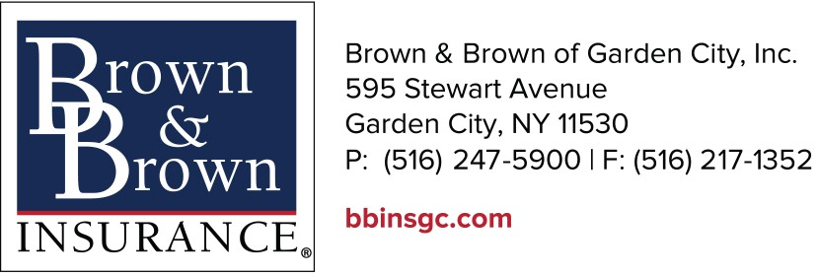
RENTAL GROUP TEMPLATE

Account Number: Reporting Month:

Named Insured:

Name of Rental Group | Date(s) | Activity Type  *Indicate Tier 1, 2, or 3 | Total # of Rental Days | Total # of Attendees | Total Event Premium

EVENTS: Activities available to rental groups including the following: | Minimum Premium
Tier 1: Activities to include: conventions; festival (at, craft, harvest); graduation; meeting (business, civic, clubs); picnic; prom; religious assemblies; reunion (family or class); seminar; social gathering/reception;  speaking engagement/lecture; wedding & reception; birthday parties held at day camps, including use of a playground, rope course, and swimming. | $100.00
Tier 2: Charity/school carnivals (no rides); concerts (bluegrass, country & western, jazz, pop rock); dances; evangelistic meetings; political rally;  school band/drill team competition. | $200.00
Tier 3: Horseback riding; groups with pool and/or lake privileges; ropes/confidence course instruction; scouting jamboree; sporting events. | $300.00

NOTE: Each group renting the facilities for more than one time (i.e.: monthly or weekly) meetings/seminars will be subject to one minimum premium provided annual attendance does not exceed 1,000 attendees.

A Commercial General Liability Minimum earned (Deposit) Policy Premium of $300.00 will apply.

RENTAL GROUP GUIDELINES

- Available to rental groups who lease camp premises and are unable to provide a certificate or other evidence of liability insurance.

- At the request of the camp, a separate liability policy (type - 08) will be issued in the name of the camp to allow the rental group to listed as an additional insured for the specific dates of the lease.

- Sexual abuse or molestation coverage, medical personnel as additional insured, and other camp enhancement coverages will not apply to the rental policy.

- The camp may report lease activity monthly or on an individual activity basis on the template provided. Each activity should include name of rental group, dates, activity type, and number of attendees.

- The minimum premium to activate the policy is $300.00.

CAMP RENTAL GROUP PROGRAM

EXPOSURES: Facility Rental Group Attendees

EXCLUSIONS: Sexual Abuse and Molestation, Additional Insured: Medical Personnel

This page applies to rental group activities held on the camp premises during the off-season that are not sponsored by the insured and for which a certificate of insurance is not available from the rental group.

LIMITS: $3,000,000 General Aggregate Limit
$1,000,000 Products-Completed Operations Aggregate Limit
$1,000,000 Each Occurrence Limit
$100,000 Damage to Premises Rented to You Limit
$5,000 Premises Medical Payments Limit

PREMIUM: Based on activity type and number of attendees (not to exceed 1,000 total attendees).

EVENTS: Activities available to rental groups including the following:

Tier 1: Activities to include: conventions; festival (at, craft, harvest); graduation; meeting (business, civic, clubs); picnic; prom; religious assemblies; reunion (family or class); seminar; social gathering/reception; speaking engagement/lecture; wedding & reception.

Tier 2: Charity/school carnivals (no rides); concerts (bluegrass, country & western, jazz, pop rock); dances; evangelistic meetings; political rally; school band/drill team competition.

Tier 3: Horseback riding; groups with pool and/or lake privileges; ropes/confidence course instruction; scouting jamboree; sporting events.

NOTE: Each group renting the facilities for more than one time (i.e.: monthly or weekly) meetings/seminars will be subject to one minimum premium provided annual attendance does not exceed 1,000 attendees.

A Commercial General Liability Minimum earned (Deposit) Policy Premium of $300.00 will apply.

